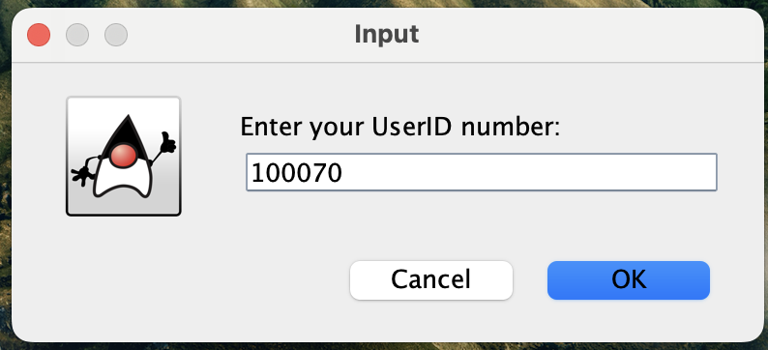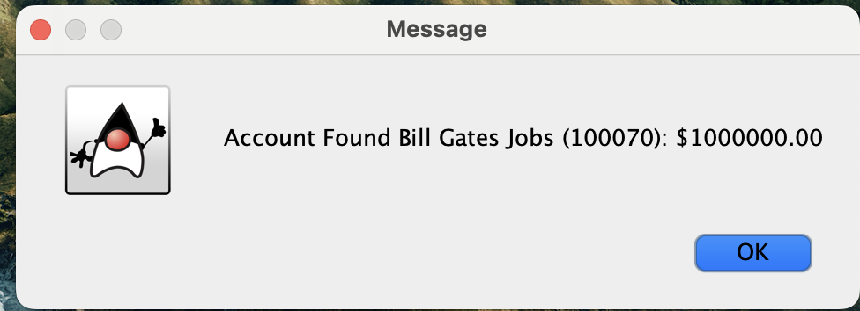

Reading: name,id,balance

Account read: John Doe (100001): $50.00

Reading: name,id,balance

Account read: Jane Doe (100002): $20.50

Reading: name,id,balance

Account read: Michael Smith (100003): $120.30

Reading: name,id,balance

Account read: Jessica Brown (100004): $70.75

Reading: name,id,balance

Account read: David Lee (100005): $90.10

Reading: name,id,balance

Account read: Jennifer Davis (100006): $60.45

Reading: name,id,balance

Account read: Brian Wilson (100007): $200.00

Reading: name,id,balance

Account read: Catherine Rodriguez (100008): $35.80

Reading: name,id,balance

Account read: Daniel Hernandez (100009): $85.25

Reading: name,id,balance

Account read: Laura Johnson (100010): $10.00

Reading: name,id,balance

Account read: Anthony Perez (100011): $15.90

Reading: name,id,balance

Account read: Megan Martin (100012): $80.60

Reading: name,id,balance

Account read: Kevin Nguyen (100013): $45.35

Reading: name,id,balance

Account read: Ashley Taylor (100014): $55.70

Reading: name,id,balance

Account read: Joshua Turner (100015): $30.25

Reading: name,id,balance

Account read: Amanda Scott (100016): $65.45

Reading: name,id,balance

Account read: Robert Clark (100017): $70.50

Reading: name,id,balance

Account read: Emily Hernandez (100018): $90.75

Reading: name,id,balance

Account read: Steven Young (100019): $40.15

Reading: name,id,balance

Account read: Taylor Allen (100020): $25.80

Reading: name,id,balance

Account read: Jacob Evans (100021): $15.50

Reading: name,id,balance

Account read: Hannah Davis (100022): $100.00

Reading: name,id,balance

Account read: Matthew Walker (100023): $75.35

Reading: name,id,balance

Account read: Kayla Jackson (100024): $55.90

Reading: name,id,balance

Account read: Christopher Baker (100025): $80.40

Reading: name,id,balance

Account read: Lauren King (100026): $95.70

Reading: name,id,balance

Account read: Erica Wright (100027): $40.90

Reading: name,id,balance

Account read: Kyle Thompson (100028): $50.80

Reading: name,id,balance

Account read: Melissa Hill (100029): $65.20

Reading: name,id,balance

Account read: Ryan Johnson (100030): $55.35

Reading: name,id,balance

Account read: Samantha Harris (100031): $25.50

Reading: name,id,balance

Account read: Brandon Garcia (100032): $30.80

Reading: name,id,balance

Account read: Kaitlyn Rodriguez (100033): $45.75

Reading: name,id,balance

Account read: William Torres (100034): $70.50

Reading: name,id,balance

Account read: Abigail Wright (100035): $90.15

Reading: name,id,balance

Account read: Nicholas Green (100036): $20.60

Reading: name,id,balance

Account read: Madison Lopez (100037): $15.70

Reading: name,id,balance

Account read: Alexander Carter (100038): $80.55

Reading: name,id,balance

Account read: Olivia Williams (100039): $50.00

Reading: name,id,balance

Account read: Jordan Martinez (100040): $100.85

Reading: name,id,balance

Account read: Jessica Brown (100041): $90.30

Reading: name,id,balance

Account read: Joshua Phillips (100042): $60.90

Reading: name,id,balance

Account read: Katherine Davis (100043): $35.75

Reading: name,id,balance

Account read: Charles Adams (100044): $25.10

Reading: name,id,balance

Account read: Natalie Campbell (100045): $45.60

Reading: name,id,balance

Account read: Jonathan Perez (100046): $70.50

Reading: name,id,balance

Account read: Julia Jackson (100047): $20.35

Reading: name,id,balance

Account read: Christopher Lee (100048): $80.90

Reading: name,id,balance

Account read: Vanessa Collins (100049): $55.20

Reading: name,id,balance

Account read: Nicholas Lewis (100050): $45.70

Reading: name,id,balance

Account read: Lauren White (100051): $15.85

Reading: name,id,balance

Account read: Alexander Flores (100052): $60.40

Reading: name,id,balance

Account read: Isabella Taylor (100053): $95.10

Reading: name,id,balance

Account read: Cameron Scott (100054): $70.00

Reading: name,id,balance

Account read: Victoria Hernandez (100055): $50.50

Reading: name,id,balance

Account read: Benjamin Allen (100056): $30.75

Reading: name,id,balance

Account read: Madison Rodriguez (100057): $80.85

Reading: name,id,balance

Account read: Ethan Hall (100058): $75.00

Reading: name,id,balance

Account read: Sophia Mitchell (100059): $40.60

Reading: name,id,balance

Account read: Aiden Thompson (100060): $55.25

Reading: name,id,balance

Account read: Emma Adams (100061): $65.35

Reading: name,id,balance

Account read: Christopher Baker (100062): $25.50

Reading: name,id,balance

Account read: Hailey Williams (100063): $80.70

Reading: name,id,balance

Account read: Andrew Martinez (100064): $35.40

Reading: name,id,balance

Account read: Elizabeth Hernandez (100065): $90.00

Reading: name,id,balance

Account read: Ryan Davis (100066): $20.50

Reading: name,id,balance

Account read: Avery Brown (100067): $65.80

Reading: name,id,balance

Account read: Jacob Turner (100068): $40.15

Reading: name,id,balance

Account read: Makayla Evans (100069): $55.00

Reading: name,id,balance

Account read: Bill Gates Jobs (100070): $1000000.00

Bank Name: VOD

John Doe (100001): $50.00

Jane Doe (100002): $20.50

Michael Smith (100003): $120.30

Jessica Brown (100004): $70.75

David Lee (100005): $90.10

Jennifer Davis (100006): $60.45

Brian Wilson (100007): $200.00

Catherine Rodriguez (100008): $35.80

Daniel Hernandez (100009): $85.25

Laura Johnson (100010): $10.00

Anthony Perez (100011): $15.90

Megan Martin (100012): $80.60

Kevin Nguyen (100013): $45.35

Ashley Taylor (100014): $55.70

Joshua Turner (100015): $30.25

Amanda Scott (100016): $65.45

Robert Clark (100017): $70.50

Emily Hernandez (100018): $90.75

Steven Young (100019): $40.15

Taylor Allen (100020): $25.80

Jacob Evans (100021): $15.50

Hannah Davis (100022): $100.00

Matthew Walker (100023): $75.35

Kayla Jackson (100024): $55.90

Christopher Baker (100025): $80.40

Lauren King (100026): $95.70

Erica Wright (100027): $40.90

Kyle Thompson (100028): $50.80

Melissa Hill (100029): $65.20

Ryan Johnson (100030): $55.35

Samantha Harris (100031): $25.50

Brandon Garcia (100032): $30.80

Kaitlyn Rodriguez (100033): $45.75

William Torres (100034): $70.50

Abigail Wright (100035): $90.15

Nicholas Green (100036): $20.60

Madison Lopez (100037): $15.70

Alexander Carter (100038): $80.55

Olivia Williams (100039): $50.00

Jordan Martinez (100040): $100.85

Jessica Brown (100041): $90.30

Joshua Phillips (100042): $60.90

Katherine Davis (100043): $35.75

Charles Adams (100044): $25.10

Natalie Campbell (100045): $45.60

Jonathan Perez (100046): $70.50

Julia Jackson (100047): $20.35

Christopher Lee (100048): $80.90

Vanessa Collins (100049): $55.20

Nicholas Lewis (100050): $45.70

Lauren White (100051): $15.85

Alexander Flores (100052): $60.40

Isabella Taylor (100053): $95.10

Cameron Scott (100054): $70.00

Victoria Hernandez (100055): $50.50

Benjamin Allen (100056): $30.75

Madison Rodriguez (100057): $80.85

Ethan Hall (100058): $75.00

Sophia Mitchell (100059): $40.60

Aiden Thompson (100060): $55.25

Emma Adams (100061): $65.35

Christopher Baker (100062): $25.50

Hailey Williams (100063): $80.70

Andrew Martinez (100064): $35.40

Elizabeth Hernandez (100065): $90.00

Ryan Davis (100066): $20.50

Avery Brown (100067): $65.80

Jacob Turner (100068): $40.15

Makayla Evans (100069): $55.00

Bill Gates Jobs (100070): $1000000.00

Process finished with exit code 0